# 实验一 基于Servlet的CRUD

一、实验目的：

熟悉并掌握运用Servlet开发模式 (HTML+JSP+JavaBean+Servlet)即MVC模式实现数据库CRUD基本编程。

二、实验内容：

在MyEclipse环境下运用HTML+JSP+JavaBean+Servlet以及JDBC技术完成相应的数据库CRUD功能，调试运行程序。

三、实验要求：

1. 熟悉并掌握运用MVC技术开发功能模块的基本步骤；

2. 运用相关技术（HTML+JSP+JavaBean+Servlet以及JDBC）完成规定功能；

3. 写出实验报告。

四、实验步骤：

1．进入MyEclipse环境，新建一个Web Project。

我这里用的是IDEA环境，新建Java Enterprise项目

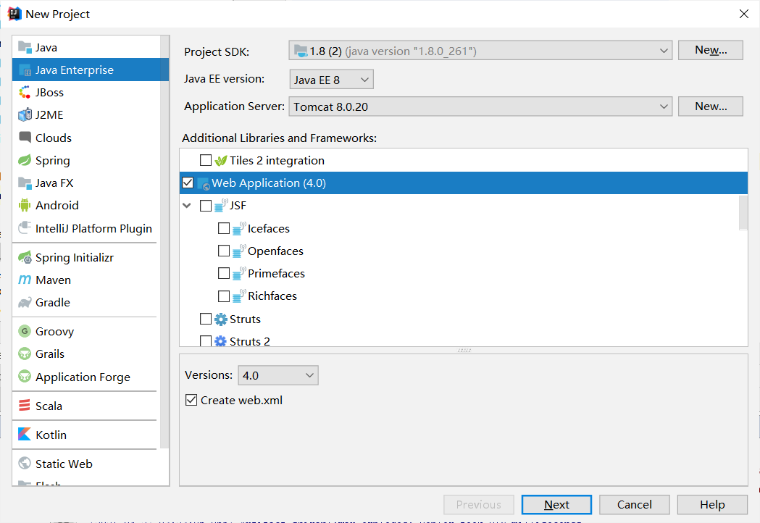

1. 设计数据库表结构。

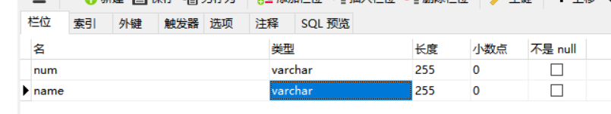

1. 采用MVC技术完成数据库的CRUD

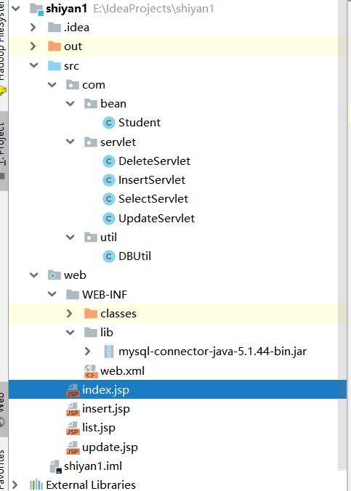

关键代码:

DBUtil

**package** com.util;  
**import** java.sql.*;  
**public class** DBUtil {  
 **public static** Connection getConn(){  
 Connection conn = **null**;  
 String url = **"jdbc:mysql://localhost:3306/javaeeshiyan?useSSL=false&useUnicode=true&characterEncoding=UTF-8&zeroDateTimeBehavior=convertToNull&allowMultiQueries=true"**;  
 String user = **"root"**;  
 String pwd = **"123456"**;  
  
  
 **try** {  
 Class.*forName*(**"com.mysql.jdbc.Driver"**);  
 conn = DriverManager.*getConnection*(url, user, pwd);  
 } **catch** (SQLException e) {  
 *//* ***TODO Auto-generated catch block*** e.printStackTrace();  
 } **catch** (ClassNotFoundException e) {  
 *//* ***TODO Auto-generated catch block*** e.printStackTrace();  
 }  
 **return** conn;  
 }  
  
 **public static void** closeConn(Connection conn, PreparedStatement ps, ResultSet rs){  
 **if**(conn!=**null**){  
 **try** {  
 conn.close();  
 } **catch** (SQLException e) {  
 *//* ***TODO Auto-generated catch block*** e.printStackTrace();  
 }  
 }  
 **if**(ps!=**null**){  
 **try** {  
 ps.close();  
 } **catch** (SQLException e) {  
 *//* ***TODO Auto-generated catch block*** e.printStackTrace();  
 }  
 }  
 **if**(rs!=**null**){  
 **try** {  
 rs.close();  
 } **catch** (SQLException e) {  
 *//* ***TODO Auto-generated catch block*** e.printStackTrace();  
 }  
 }  
 }  
}

Student

**package** com.bean;  
  
**public class** Student {  
 **private** String **num**;  
 **private** String **name**;  
  
 **public** Student() {  
 **super**();  
 *//* ***TODO Auto-generated constructor stub*** }  
  
 **public** Student( String name, String num) {  
 **super**();  
 **this**.**num** = num;  
 **this**.**name** = name;  
 }  
 **public** String getNum() {  
 **return num**;  
 }  
  
 **public void** setNum(String num) {  
 **this**.**num** = num;  
 }  
  
 **public** String getName() {  
 **return name**;  
 }  
  
 **public void** setName(String name) {  
 **this**.**name** = name;  
 }  
}

InsertServlet

**package** com.servlet;  
  
**import** javax.servlet.ServletException;  
**import** javax.servlet.annotation.WebServlet;  
**import** javax.servlet.http.HttpServlet;  
**import** javax.servlet.http.HttpServletRequest;  
**import** javax.servlet.http.HttpServletResponse;  
**import** java.io.IOException;  
**import** java.io.PrintWriter;  
**import** java.sql.Connection;  
**import** java.sql.PreparedStatement;  
**import** java.sql.SQLException;  
  
  
**import** com.util.DBUtil;  
  
@WebServlet(name = **"InsertServlet"**,urlPatterns = **"/InsertServlet"**)  
**public class** InsertServlet **extends** HttpServlet {  
 **protected void** doPost(HttpServletRequest request, HttpServletResponse response) **throws** ServletException, IOException {  
 request.setCharacterEncoding(**"utf-8"**);  
 response.setCharacterEncoding(**"utf-8"**);  
 response.setContentType(**"text/html;charset=UTF-8"**);  
 String num = request.getParameter(**"num"**);  
 String name = request.getParameter(**"name"**);  
  
 Connection conn = DBUtil.*getConn*();  
 PreparedStatement ps = **null**;  
 String sql = **"insert into students(num,name) values(?,?)"**;  
 PrintWriter out = response.getWriter();  
 **int** i=0;  
 **try** {  
 ps = conn.prepareStatement(sql);  
 ps.setString(1,num);  
 ps.setString(2,name);  
 i=ps.executeUpdate();  
  
 } **catch** (SQLException e) {  
 e.printStackTrace();  
 }**finally** {  
 DBUtil.*closeConn*(conn,ps,**null**);  
 }  
 **if**(i>=1){out.print(**"<script>alert('添加成功!');window.location.href='SelectServlet'</script>"**);}  
 **else**{out.print(**"<script>alert('添加失败!');window.location.href='SelectServlet'</script>"**);}  
 *//response.sendRedirect("select");//重定向网页，转到指定的页面。* }  
  
 **protected void** doGet(HttpServletRequest request, HttpServletResponse response) **throws** ServletException, IOException {  
 doPost(request,response);  
 }  
}

DeleteServlet

**package** com.servlet;  
  
**import** com.util.DBUtil;  
  
**import** javax.servlet.ServletException;  
**import** javax.servlet.annotation.WebServlet;  
**import** javax.servlet.http.HttpServlet;  
**import** javax.servlet.http.HttpServletRequest;  
**import** javax.servlet.http.HttpServletResponse;  
**import** java.io.IOException;  
**import** java.io.PrintWriter;  
**import** java.sql.Connection;  
**import** java.sql.PreparedStatement;  
**import** java.sql.SQLException;  
  
@WebServlet(name = **"DeleteServlet"**,urlPatterns = **"/DeleteServlet"**)  
**public class** DeleteServlet **extends** HttpServlet {  
 **protected void** doPost(HttpServletRequest request, HttpServletResponse response) **throws** ServletException, IOException {  
 request.setCharacterEncoding(**"utf-8"**);  
 response.setCharacterEncoding(**"utf-8"**);  
 response.setContentType(**"text/html;charset=UTF-8"**);  
 String num = request.getParameter(**"num"**);  
 System.***out***.println(**"num:::"**+num);  
 Connection conn = DBUtil.*getConn*();  
 PreparedStatement ps = **null**;  
 String sql = **"delete from students where num = ?"**;  
 PrintWriter out = response.getWriter();  
 **int** i=0;  
 **try** {  
 ps = conn.prepareStatement(sql);  
 ps.setString(1,num);  
 i= ps.executeUpdate();  
  
 } **catch** (SQLException e) {  
 e.printStackTrace();  
 }**finally** {  
 DBUtil.*closeConn*(conn,ps,**null**);  
 }  
 *//response.sendRedirect("SelectServlet");* **if**(i>=1){out.print(**"<script>alert('删除成功!');window.location.href='SelectServlet'</script>"**);}  
 **else**{out.print(**"<script>alert('删除失败!');window.location.href='SelectServlet'</script>"**);}  
 }  
  
 **protected void** doGet(HttpServletRequest request, HttpServletResponse response) **throws** ServletException, IOException {  
 doPost(request,response);  
 }  
}

SelectServlet

**package** com.servlet;  
  
**import** javax.servlet.ServletException;  
**import** javax.servlet.annotation.WebServlet;  
**import** javax.servlet.http.HttpServlet;  
**import** javax.servlet.http.HttpServletRequest;  
**import** javax.servlet.http.HttpServletResponse;  
**import** javax.servlet.http.HttpSession;  
**import** java.io.IOException;  
**import** java.sql.Connection;  
**import** java.sql.PreparedStatement;  
**import** java.sql.ResultSet;  
**import** java.sql.SQLException;  
**import** java.util.ArrayList;  
**import** java.util.List;  
  
**import** com.util.DBUtil;  
**import** com.bean.Student;  
@WebServlet(name = **"SelectServlet"**,urlPatterns = **"/SelectServlet"**)  
**public class** SelectServlet **extends** HttpServlet {  
 **protected void** doPost(HttpServletRequest request, HttpServletResponse response) **throws** ServletException, IOException {  
 request.setCharacterEncoding(**"utf-8"**);  
 response.setCharacterEncoding(**"utf-8"**);  
  
 Connection conn = DBUtil.*getConn*();  
 PreparedStatement ps = **null**;  
 ResultSet rs = **null**;  
 String sql = **"select** *\** **from students"**;  
 List<Student> students = **new** ArrayList<Student>();  
  
 **try** {  
 ps = conn.prepareStatement(sql);  
 rs = ps.executeQuery();  
 **while** (rs.next()){  
 Student student = **new** Student(rs.getString(2),rs.getString(1));  
 students.add(student);  
 }  
 } **catch** (SQLException e) {  
 e.printStackTrace();  
 }**finally** {  
 DBUtil.*closeConn*(conn,ps,rs);  
 }  
 HttpSession session = request.getSession();  
 session.setAttribute(**"stu"**,students);  
 response.sendRedirect(**"list.jsp"**);  
 }  
  
 **protected void** doGet(HttpServletRequest request, HttpServletResponse response) **throws** ServletException, IOException {  
 doPost(request,response);  
 }  
}

UpdateServlet

**package** com.servlet;  
  
**import** javax.servlet.ServletException;  
**import** javax.servlet.annotation.WebServlet;  
**import** javax.servlet.http.HttpServlet;  
**import** javax.servlet.http.HttpServletRequest;  
**import** javax.servlet.http.HttpServletResponse;  
**import** java.io.IOException;  
**import** java.io.PrintWriter;  
**import** java.sql.Connection;  
**import** java.sql.PreparedStatement;  
**import** java.sql.SQLException;  
  
**import** com.util.DBUtil;  
@WebServlet(name = **"UpdateServlet"**,urlPatterns = **"/UpdateServlet"**)  
**public class** UpdateServlet **extends** HttpServlet {  
 **protected void** doPost(HttpServletRequest request, HttpServletResponse response) **throws** ServletException, IOException {  
 request.setCharacterEncoding(**"utf-8"**);  
 response.setCharacterEncoding(**"utf-8"**);  
 response.setContentType(**"text/html;charset=UTF-8"**);  
 String num = request.getParameter(**"num"**);  
 String name = request.getParameter(**"name"**);  
*// System.out.println("num''''"+num);  
// System.out.println("name''''"+name);* Connection conn = DBUtil.*getConn*();  
 PreparedStatement ps = **null**;  
 String sql = **"update students set name=? where num = ?"**;  
 PrintWriter out = response.getWriter();  
 **int** i=0;  
 **try** {  
 ps = conn.prepareStatement(sql);  
 ps.setString(1,name);  
 ps.setString(2,num);  
 i=ps.executeUpdate();  
 } **catch** (SQLException e) {  
 e.printStackTrace();  
 }**finally** {  
 DBUtil.*closeConn*(conn,ps,**null**);  
 }  
 *//response.sendRedirect("SelectServlet");* **if**(i>=1){out.print(**"<script>alert('修改成功!');window.location.href='SelectServlet'</script>"**);}  
 **else**{out.print(**"<script>alert('修改失败!');window.location.href='SelectServlet'</script>"**);}  
}  
  
 **protected void** doGet(HttpServletRequest request, HttpServletResponse response) **throws** ServletException, IOException {  
 doPost(request,response);  
 }  
}

List.jsp

<%@ **page import**="**java.util.List**" %>  
<%@ **page import**="**com.bean.Student**" %>  
<%@ **page import**="**java.util.ArrayList**" %>  
<%@ **page contentType**="**text/html;charset=UTF-8**" **language**="**java**" %>  
<**html**>  
<**head**>  
 <**title**>学生信息</**title**>  
</**head**>  
<**body**>  
<**table border="1" align="center"**>  
 <**thead**>  
 <**tr**>  
 <**td**>  
 学号  
 </**td**>  
 <**td**>  
 姓名  
 </**td**>  
 <**td colspan="2"**>  
 操作  
 </**td**>  
 <**td**>  
  
 </**td**>  
 <**td**>  
 <**a href="insert.jsp"**>添加</**a**>  
 </**td**>  
 </**tr**>  
 </**thead**>  
 <**tbody**>  
 **<%** List<Student> students = (ArrayList)session.getAttribute(**"stu"**);  
 **for** (Student student : students){  
 **%>** <**tr**>  
 <**td**>  
 **<%=**student.getNum() **%>** </**td**>  
 <**td**>  
 **<%=**student.getName() **%>** </**td**>  
 <**td**>  
 <**a href="DeleteServlet?num=<%=**student.getNum() **%>"**>删除</**a**>  
 </**td**>  
 <**td**>  
 <**a href="update.jsp?num=<%=**student.getNum() **%>"**>更新</**a**>  
 </**td**>  
 </**tr**>  
 **<%** }  
 **%>** </**tbody**>  
</**table**>  
  
</**body**>  
</**html**>

Insert.jsp

<%@ **page contentType**="**text/html;charset=UTF-8**" **language**="**java**" %>  
<**html**>  
<**head**>  
 <**title**>添加</**title**>  
</**head**>  
<**body**>  
<**div style="width**:100%;**text-align**:**center"**>  
<**form action="InsertServlet" method="post"**>  
 学号：<**input type="text" name="num"**><**br**>  
 姓名：<**input type="text" name="name"**><**br**>  
 <**input type="submit" value="添加"**>  
</**form**>  
 <**a href="SelectServlet"**>返回</**a**>  
</**div**>  
</**body**>  
</**html**>

Update.jsp

<%@ **page import**="**java.sql.Connection**" %>  
<%@ **page import**="**com.util.DBUtil**" %>  
<%@ **page import**="**java.sql.PreparedStatement**" %>  
<%@ **page import**="**java.sql.ResultSet**" %>  
  
<%@ **page contentType**="**text/html;charset=UTF-8**" **language**="**java**" %>  
<**html**>  
<**head**>  
 <**title**>更新</**title**>  
</**head**>  
<**body**>  
  
**<%** request.setCharacterEncoding(**"utf-8"**);  
 response.setCharacterEncoding(**"utf-8"**);  
  
 String num = request.getParameter(**"num"**);  
  
 Connection conn = DBUtil.*getConn*();  
 PreparedStatement ps = **null**;  
 ResultSet rs = **null**;  
 String sql = **"select** *\** **from students where num = ?"**;  
 **try**{  
 ps = conn.prepareStatement(sql);  
 ps.setString(1,num);  
 rs = ps.executeQuery();  
 **while** (rs.next()){  
 String num1 = rs.getString(**"num"**);  
 String name = rs.getString(**"name"**);  
**%>**<**div style="width**:100%;**text-align**:**center"**>  
<**form action="UpdateServlet" method="post"**>  
 学号：<**input type="text" name="num" value="<%=**num1 **%>" readonly="true"**><**br**>  
 姓名：<**input type="text" name="name" value="<%=**name **%>"**><**br**>  
 <**input type="submit" value="修改"**>  
</**form**>  
 <**a href="SelectServlet"**>返回</**a**>  
</**div**>  
**<%** }  
 }**catch** (Exception e){  
 e.printStackTrace();  
 }**finally** {  
 DBUtil.*closeConn*(conn,ps,rs);  
 }  
**%>**</**body**>  
</**html**>

1. 程序运行截图。

显示学生信息：

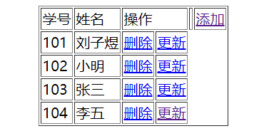

添加：

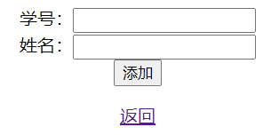

更新：

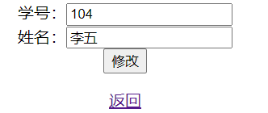

删除：

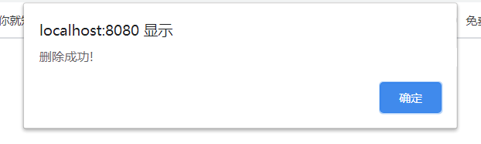

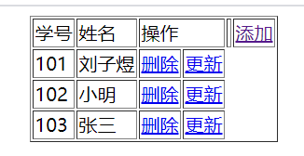

1. 心得体会：

本次实验进行了基于Servlet的数据库增删改查的操作，由于之前学习过servlet，所以还是蛮顺利就完成了，对于数据的传输，很好的学习了并掌握了其中方法和注意事项，包括中文乱码的解决。